|  |
| --- |
| Tutorial 11(Week starting on 30-may-2022) |

|  |
| --- |
| **Objectives**   * Studying the economic impacts of the Black Death * Learn about geospatial data. * Replicate maps with QGIS.   **Working materials**   * **Jedwab, Remi, Noel D. Johnson, and Mark Koyama.** [2022]. "The Economic Impact of the Black Death." *Journal of Economic Literature*, 60(1):132-78. * **QGIS[1]** * You will need the folder Figure1 which can be found on the virtual campus[2]. |

**Exercise guide**

The exercises marked with an asterisk (*) are compulsory and must be submitted by email **before 12.00 on Wednesday 8th June**. [3] To the mark obtained on the evaluation of this assignment, **0.05 points will be subtracted for each minute late**. Consult the course program with regards to the formalities of the presentation.

1. (*) Explain in a few words what the question the authors are trying to answer. What are the main results?
2. Why do the authors claim that the Black Death was an exogenous shock?
3. Identify the georeferenced objects used to calculate the market access index for cities.
4. What should be the impact of the Black Death on wages according to the Malthusian model? What differs in the Smithian framework?
5. (*) Replicate below figure (which corresponds to Figure 1 of the paper) using data from shapefiles in the "Figure1" folder.

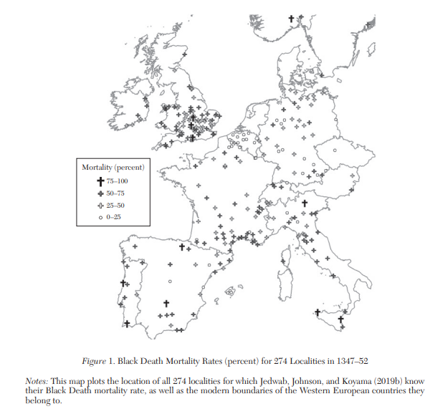

1. They try to answer whether black death was an exogenous mortality shock and what could have been the political and economic effects of the plague. They find that, before 1300 city characteristics were unrelated to mortality, limiting the potential for endogeneity. Also, that it influenced prices and that, through a Malthusian logic, wages rose, and inequality diminished, although, in the long term, those effects dwindled at different rates and stabilize afterwards. On the political side, they explain how states gained power in tax collecting as salaries extend past subsistence level and it is therefore plausible to charge more.

2. They think the plague was an exogenous shock because the prevailing conditions pre-black death weren’t sufficient for it to be exogenous, in the sense that the mortality rates for cities were not determined by some other factor like density or market access (trade potential). The first-hit did not match characteristics one would expect if it were endogenous, like big population size or amount of trade. In any case, they say “random factors compensated for non-random factors” in the spread of the disease.

3. The market access index might have been drawn from georeferenced objects like known major trade centers and ports and calculating every city’s best-case distance to them, so a city further from ports and major trade centers would have a lower market access.

4. According to Malthus, they should increase because, as workforce diminishes, demand for work doesn’t so higher wages needs to be offered to cover for the offset. The ratio of labour to land and to capital are going to increase with all those deaths and therefore per capita income should be higher. Smith, instead, proposes that know-how is lost, and the progress of knowledge is stalled, so even though incomes grow, GDP doesn’t at the same rate; it lags. The market was internally in shambles with such a great shock which in turn prevents wages from rising even further than they would in a purely Malthusian frame. Nevertheless, the authors say a Malthusian approach is better fit to account for the evidence of the period.

1. Optional reference material:

   * **Graser, A [2013]** “Learning QGIS 2.0”. Packt Publishing.
   * **Bruy, A. and D. Svidzinska. [2015]** “QGIS by example”. Packt Publishing
   * **QGIS User Guide** <https://docs.qgis.org/2.18/en/docs/user_manual/>
   * **QGIS Training Manual** <https://docs.qgis.org/2.18/en/docs/training_manual/>
   * **A gentle introduction to QGIS** <https://docs.qgis.org/2.18/en/docs/gentle_gis_introduction/>

  
2. The folders contain shapefiles available in the online appendix of Jedwab, Johnson and Koyama (2022).
3. Check the course’s syllabus on presentation.